**Jamming-Aware Traffic Allocation for Multiple-Path Routing Using Portfolio Selection**

**Abstract:**

Multiple-path source routing protocols allow a data source node to distribute the total traffic among available paths. In this article, we consider the problem of jamming-aware source routing in which the source node performs traffic allocation based on empirical jamming statistics at individual network nodes. We formulate this traffic allocation as a lossy network flow optimization problem using portfolio selection theory from financial statistics. We show that in multi-source networks, this centralized optimization problem can be solved using a distributed algorithm based on decomposition in network utility maximization (NUM). We demonstrate the network’s ability to estimate the impact of jamming and incorporate these estimates into the traffic allocation problem. Finally, we simulate the achievable throughput using our proposed traffic allocation method in several scenarios.



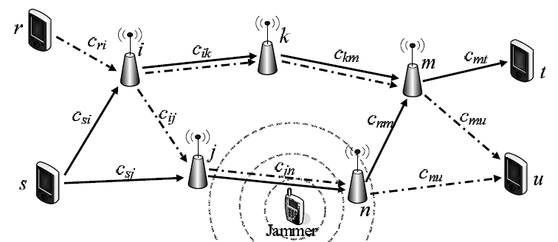

**Existing System:**

To distribute the total traffic among available paths the source node performs traffic allocation based on empirical jamming statistics at individual network nodes. If any path to be disturbed/jammed a routing path is requested an existing routing path is not be updated, the responding nodes along the path will disconnect the routing path.

**Disadvantage:**

* disturb wireless communications
* proactive / reactive
* constant, random, repeat, deceive
* single bit/packet
* outsider / insider
* Time Delay

**Proposed System:**

We propose techniques for the network nodes to estimate and characterize the impact of jamming and for a source node to incorporate these estimates into its traffic allocation. We show that in multi-source networks, this centralized optimization problem can be solved using a distributed algorithm based on decomposition in network utility maximization. We formulate this traffic allocation as a lossy network flow optimization problem using portfolio selection theory from financial statistics which allow individual network nodes to locally characterize the jamming impact and aggregate this information for the source nodes. We demonstrate that the use of portfolio selection theory allows the data sources to balance the expected data throughput with the uncertainty in achievable traffic rates.

Advantage:

Each time a new routing path is requested or an existing routing path is updated, the responding nodes along the path will relay the necessary parameters to the source node as part of the reply message for the routing path.

*Goal: Efficiently allocate the traffic to maximize the overall throughput.*

**Modules**

1. Allocation of traffic across multiple routing paths
2. Characterizing The Impact Of Jamming
3. Effect of Jammer Mobility on Network
4. Estimating End-to-End Packet Success Rates
5. Optimal Jamming-Aware Traffic Allocation

**Modules Description**

**1. Allocation of traffic across multiple routing paths:-**

We formulate the problem of allocating traffic across multiple routing paths in the presence of jamming as a lossy network flow optimization problem. We map the optimization problem to that of asset allocation using portfolio selection theory which allows individual network nodes to locally characterize the jamming impact and aggregate this information for the source nodes.

**2. Characterizing The Impact Of Jamming:-**

In these Module the network nodes to estimate and characterize the impact of jamming and for a source node to incorporate these estimates into its traffic allocation. In order for a source node s to incorporate the jamming impact in the traffic allocation problem, the effect of jamming on transmissions over each link must be estimated. However, to capture the jammer mobility and the dynamic effects of the jamming attack, the local estimates need to be continually updated.

**3. Effect of Jammer Mobility on Network:-**

The capacity indicating the link maximum number of packets persecond (pkt/s) eg:200 pkts/s which can be transported over the wireless link. Whenever the source is generating data at a rate of 300 pkts/s to be transmitted at the time jamming to be occurring. Then the throughput rate to be less. If the source node becomes aware of this effect the allocation of traffic can be changed to 150 pkts/s on each of paths thus recovers the jamming path.

**4. Estimating End-to-End Packet Success Rates:-**

The packet success rate estimates for the links in a routing path, the source needs to estimate the effective end-to-end packet success rate to determine the optimal traffic allocation. Assuming the total time required to transport packets from each source s to the corresponding destination is negligible compared to the update relay period.

**5. Optimal Jamming-Aware Traffic Allocation:-**

An optimization framework for jamming-aware traffic allocation to multiple routing paths for each source node. We develop a set of constraints imposed on traffic allocation solutions and then formulate a utility function for optimal traffic allocation by mapping the problem to that of portfolio selection in finance.

**System Requirements:**

**Hardware Required:**

* System : Pentium IV 2.4 GHz
* Hard Disk : 40 GB
* Floppy Drive : 1.44 MB
* Monitor : 15 VGA color
* Mouse : Logitech
* Keyboard : 110 Keys enhanced
* RAM : 256MB

**Software Required:**

* O/S : Windows XP.
* Language : Asp.Net, c#.
* Database : Sql-Server 2005